**Fonts with ttf files**

Demonstrations of using X3D’s <Text> and <FontStyle> nodes. This allows X3D to use .ttf (true type font) files and set the size, style (plan, bold italic, bold italic) and justification (left, center, right).

To run these demonstrations, place the .ttf files into Android Studio’s assets folder, same location as texture maps and .x3d files.

**font_multipleFonsts.x3d**

Demonstrates multiple fonts in a scene.

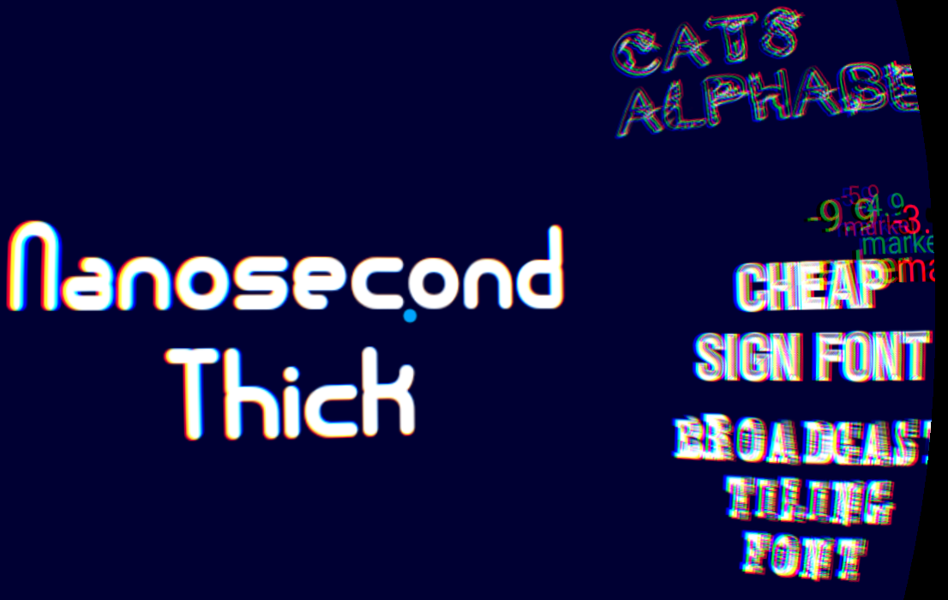

The Cheap Sign Font has a 40 second animation from (0,0,-2) to (0,0,-3), (0,0-4), (0,0,-5) to (0,0,-10), stopping 4 seconds at each position. This helps see if there are any rendering issues as the image gets smaller. Markers along the way identify its location (0,0,-1.9), (0,0,-2.9), etc.

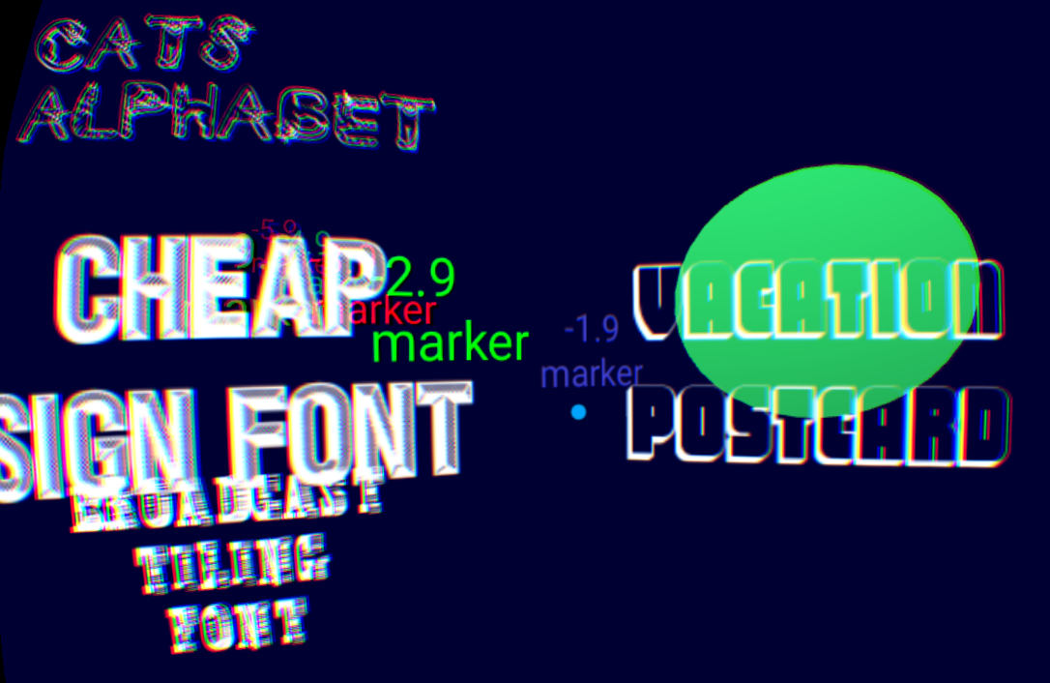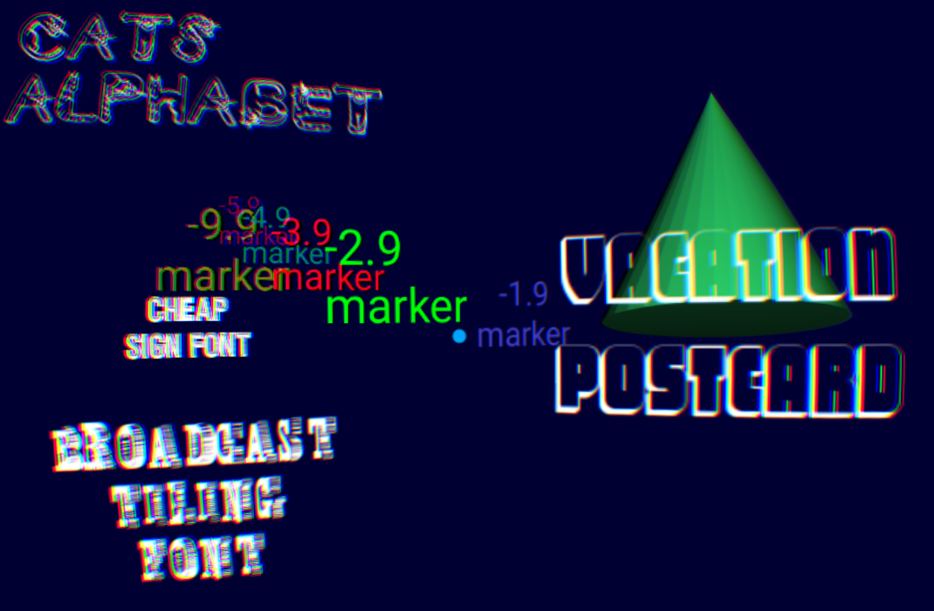

An animated green Cone was added to test with a non-text object.

**font_sizeStyleJustification.x3d**

Demonstrates changing the font size, justification and style.

On the left is setting the ‘Nanosecond Thick’ font size to 1.0, 2.0 and 3.0.

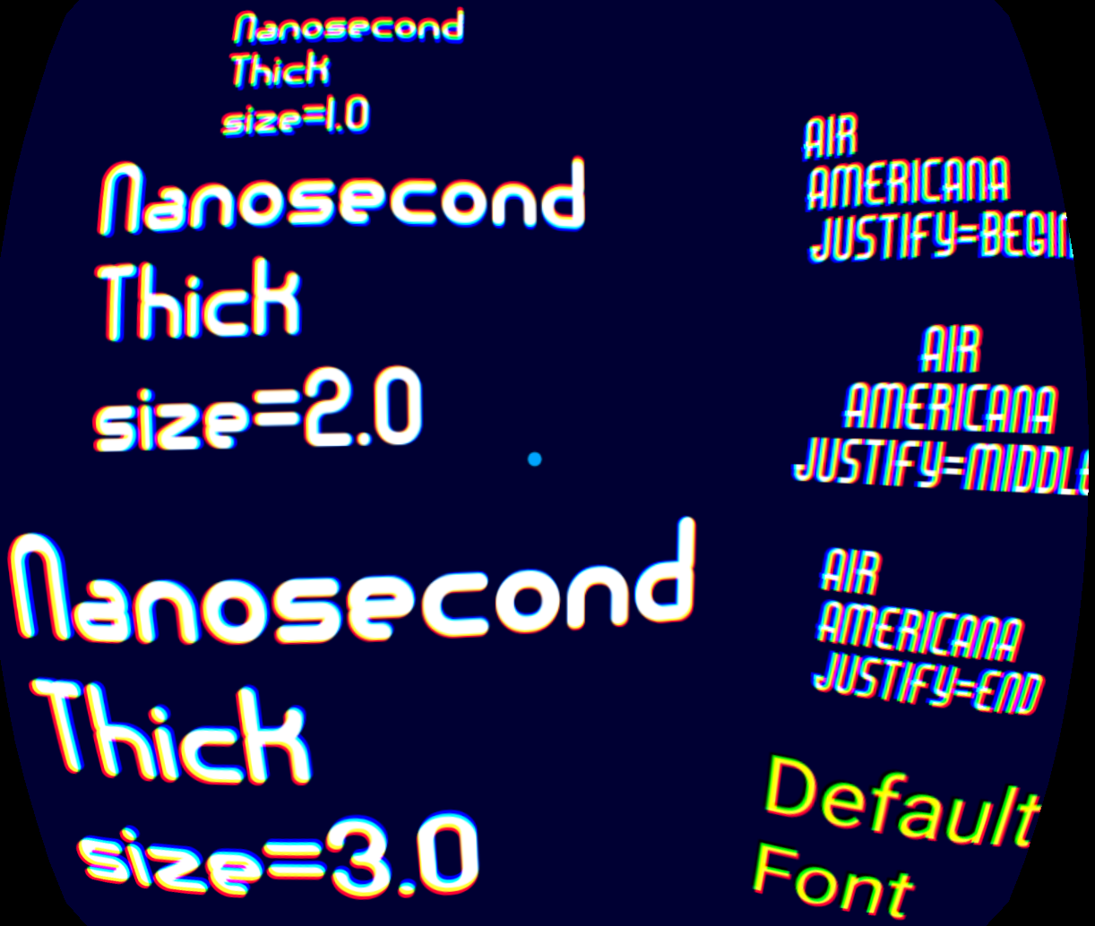

On the right is the Prisma font style set to plain, bold, italic and bold-italic from top to bottom.

In the center is the justification set to begin (left edge), middle / centered, and to the end (right edge) using the ‘Air Americana’ font. The right edge doesn’t appear to work in GearVR, however, an internally build 2d Android app showing fonts the settings used in our code is correct.

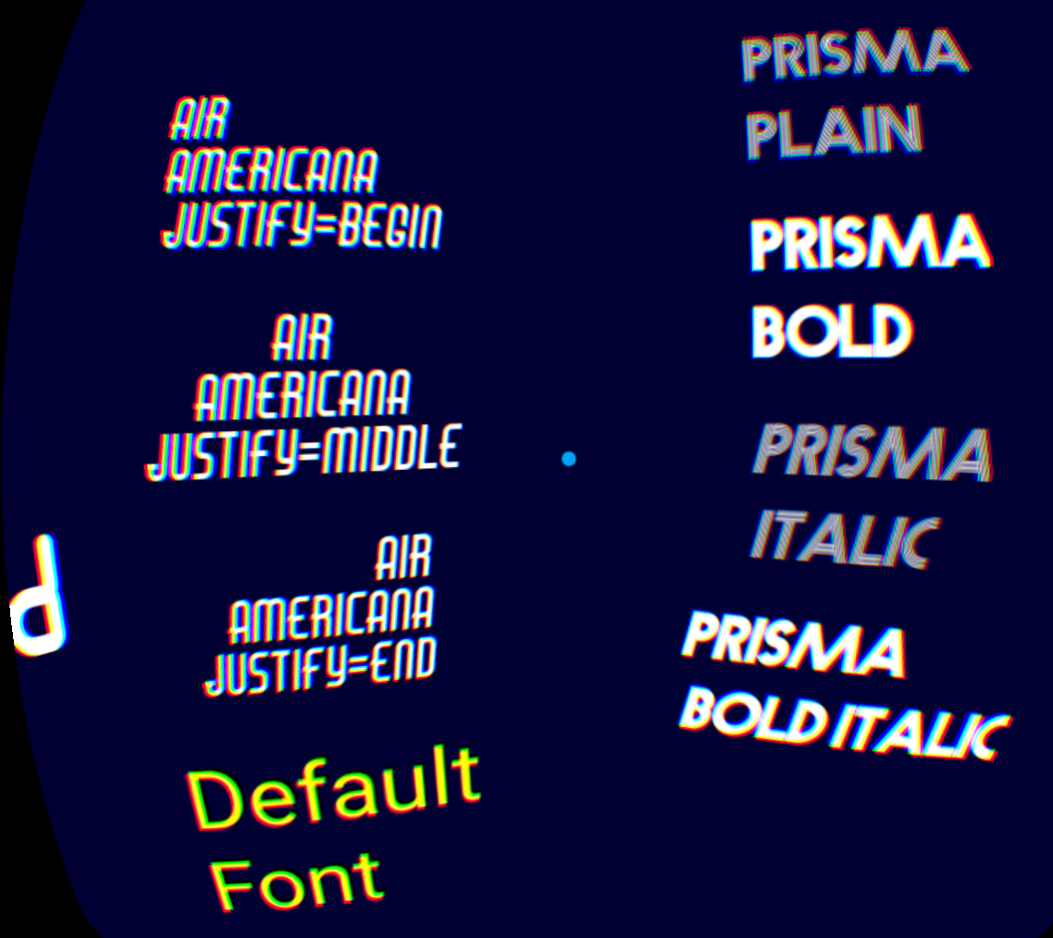

At the bottom is a default font and no X3D <FontStyle> settings. Material diffuseColor = (1, 1, 0) yellow.